**3.Branching and Merging**

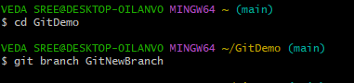1.move to gitdemo and create a new branch

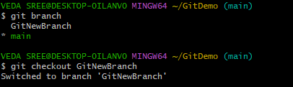2. list all local and remote branches available in current trunck and move to new branch

3. add files in new branch with contents and commit them

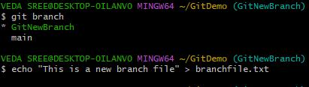

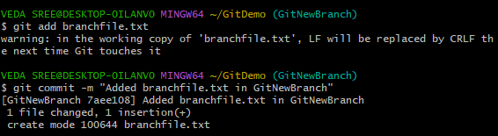

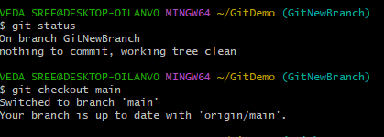4. check status and checkout to main(switch to master)

MERGING

5. list out differences between trunck and branch and merge branch and trunck

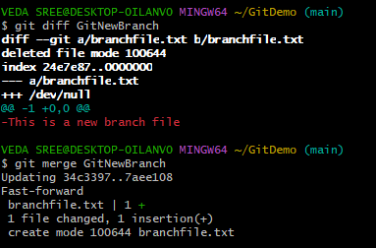

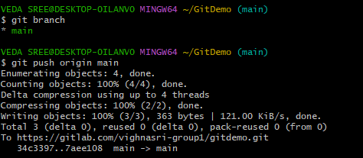

6. logging after merging and delete branch

